Project Planning Phase
Project Planning Template (Product Backlog, Sprint Planning, Stories, Story points)

Date | 30 September 2026
Team ID
Project Name | AI Study Buddy API
Maximum Marks | 5 Marks
Product Backlog, Sprint Schedule, and Estimation (4 Marks)
Use the below template to create product backlog and sprint schedule
Sprint | Functional Requirement (Epic) | User Story Number | User Story / Task | Story Points | Priority | Team Members
Sprint-1 | Registration | USN-1 | As a user, I can register for the application by entering my email, password, and confirming my password. | 2 | High
Sprint-1 | Login | USN-2 | As a user, I can log into the application by entering email & password. | 1 | High
Sprint-1 | API Access | USN-3 | As a developer, I can generate and manage an API key so that I can securely call the Study Buddy API. | 3 | High
Sprint-1 | Explain Topics | USN-4 | As a student, I can send a topic to /explain and get a clear explanation with an example. | 5 | High
Sprint-1 |  | USN-5 | As a student, I can choose my level (beginner / intermediate / advanced) so that the explanation matches my understanding. | 3 | High
Sprint-1 | API Access | USN-6 | As a developer, I get clear error messages and rate limiting so that the API is reliable and fair to use. | 3 | High
Sprint-1 | Documentation | USN-7 | As a developer, I can read Swagger / Postman API documentation so that I can integrate quickly. | 3 | Medium
Sprint-2 | Practice Quizzes | USN-8 | As a student, I can generate a quiz from a topic so that I can test my understanding. | 5 | High
Sprint-2 |  | USN-9 | As a student, I receive instant feedback and explanations on my quiz answers. | 3 | High
Sprint-2 |  | USN-10 | As a student, I can ask for a hint instead of the full answer so that I learn by thinking. | 2 | Medium
Sprint-2 | Summarize Notes | USN-11 | As a student, I can paste text and get a short summary with key points. | 3 | High
Sprint-2 |  | USN-12 | As a student, I can upload a PDF of notes and get a summary of its key formulas and definitions. | 5 | Medium
Sprint-2 | Safety | USN-13 | As a parent or teacher, I want unsafe or age-inappropriate content to be blocked so that students stay safe. | 2 | High
Sprint-3 | Study Plan | USN-14 | As a student, I can enter my exam date and topics to get a day-by-day study plan. | 5 | High
Sprint-3 |  | USN-15 | As a student, I can mark weak topics so that the plan gives them more time. | 3 | Medium
Sprint-3 | Progress Tracking | USN-16 | As a student, I can see my quiz history and progress over time. | 3 | Medium
Sprint-3 | Language Support | USN-17 | As a student, I can get explanations in my own language (for example Tamil or Hindi). | 3 | Medium
Sprint-3 | Explain Topics | USN-18 | As a student, I get answers based on my uploaded notes with the source passage shown. | 4 | Medium
Sprint-3 | Performance | USN-19 | As a developer, I get faster responses for common questions through caching. | 2 | Low
Sprint-4 | Dashboard | USN-20 | As a developer, I can view a dashboard of my API usage, limits and errors. | 5 | Medium
Sprint-4 | Practice Quizzes | USN-21 | As a student, I can create flashcards from my notes for quick revision. | 3 | Low
Sprint-4 | Testing | USN-22 | As a team, we complete user acceptance testing and fix reported bugs. | 5 | High
Sprint-4 | Deployment | USN-23 | As a team, we deploy the API to the cloud with HTTPS and monitoring. | 4 | High
Sprint-4 | Documentation | USN-24 | As a team, we finalize the documentation and demo of the project. | 3 | High

Total: 24 user stories, 80 story points across 4 sprints (20 points per sprint).
Project Tracker, Velocity & Burndown Chart: (4 Marks)
Sprint | Total Story Points | Duration | Sprint Start Date | Sprint End Date (Planned) | Story Points Completed (as on Planned End Date) | Sprint Release Date (Actual)
Sprint-1 | 20 | 6 Days | 05 Oct 2026 | 10 Oct 2026
Sprint-2 | 20 | 6 Days | 12 Oct 2026 | 17 Oct 2026
Sprint-3 | 20 | 6 Days | 19 Oct 2026 | 24 Oct 2026
Sprint-4 | 20 | 6 Days | 26 Oct 2026 | 31 Oct 2026
Velocity:
Each sprint lasts 6 days and the team’s velocity is 20 story points per sprint. The team’s average velocity (AV) per iteration unit (story points per day) is:
AV = Sprint velocity / Sprint duration = 20 / 6 ≈ 3.33 story points per day
At this velocity, the 80-point backlog is planned to finish in 4 sprints (24 days).
Burndown Chart:
A burn down chart is a graphical representation of work left to do versus time. It is often used in agile software development methodologies such as Scrum. However, burn down charts can be applied to any project containing measurable progress over time.
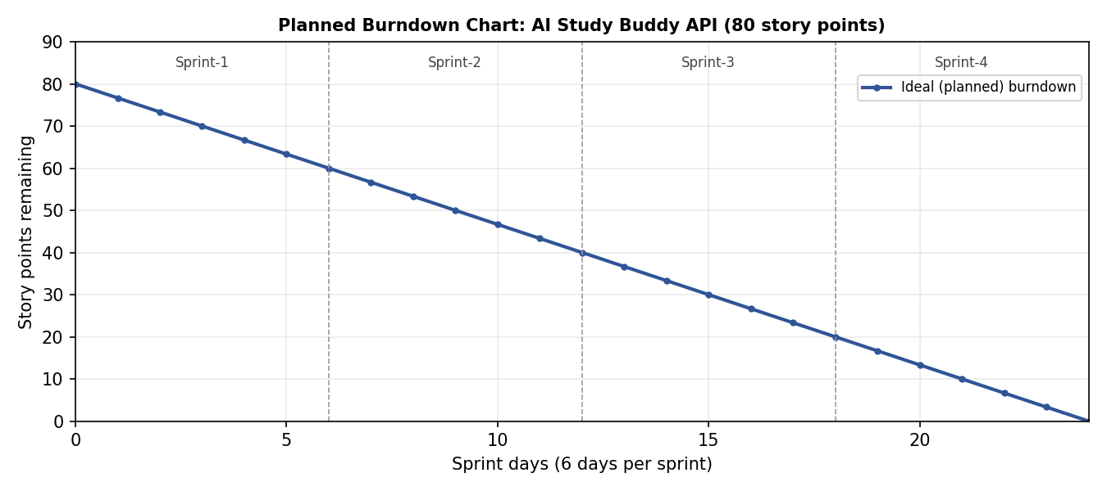
Figure 1: Planned burndown. Add the actual remaining points after each sprint day to compare.
https://www.visual-paradigm.com/scrum/scrum-burndown-chart/
https://www.atlassian.com/agile/tutorials/burndown-charts
Reference:
https://www.atlassian.com/agile/project-management
https://www.atlassian.com/agile/tutorials/how-to-do-scrum-with-jira-software
https://www.atlassian.com/agile/tutorials/epics
https://www.atlassian.com/agile/tutorials/sprints
https://www.atlassian.com/agile/project-management/estimation
https://www.atlassian.com/agile/tutorials/burndown-charts

